Quadratic Functions Practice – parabolas, completing the square

1. For the quadratic function $f\left(x\right)={(x-3)}^{2}+7$ give

|  |  |  |
| --- | --- | --- |
| a | vertex |  |
| b | equation of the axis of symmetry |  |
| c | y- intercept |  |
| d | x- intercept(s) |  |
| e | domain |  |
| f | range |  |

2. Convert the quadratic equation below to the form C:\Users\Jane\AppData\Local\Temp\ksohtml10380\wps57.jpg

C:\Users\Jane\AppData\Local\Temp\ksohtml10380\wps58.jpg

3. Write equations in C:\Users\Jane\AppData\Local\Temp\ksohtml10380\wps64.jpg form for the described parabolas:

a) Vertex (0, 5); passes through (2, 9)

b) Vertex (8, 3); opens down

c) Y-intercept 6; maximum value of 14 when x=2

4. Draw a graph of C:\Users\Jane\AppData\Local\Temp\ksohtml10380\wps66.jpg

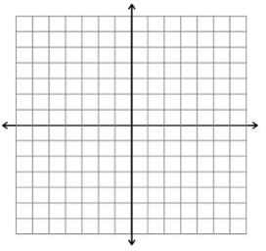

5. Draw a graph of C:\Users\Jane\AppData\Local\Temp\ksohtml10380\wps68.jpg

